Recipe 10-3: Determining the Database Identifier

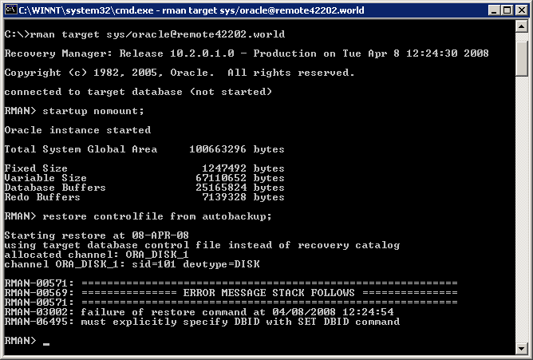
Determine the DBID from SQL code:
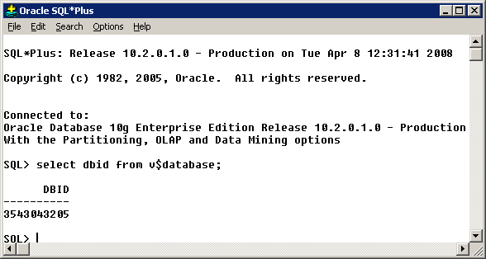
Determine DBID from starting up RMAN in a setting where the database is open:
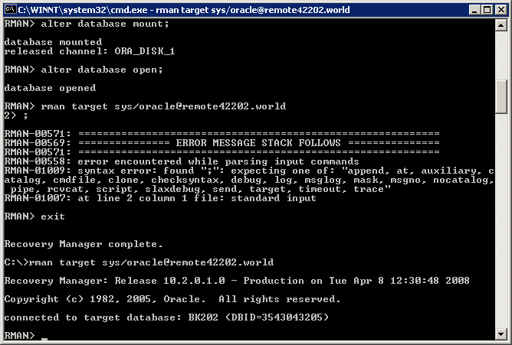

Recipe 10-5: Restoring Control File to Nondefault Location

…using autobackups
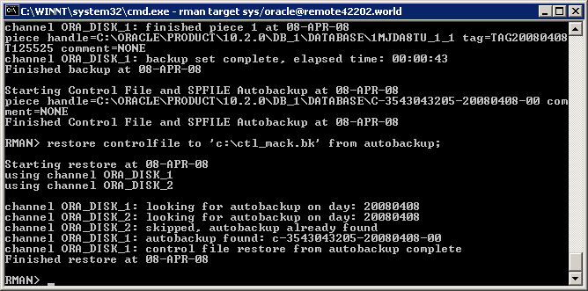

…using a recovery catalog
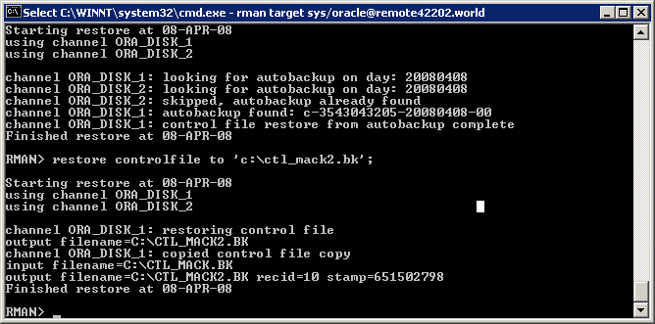

…from a manually configured backup piece
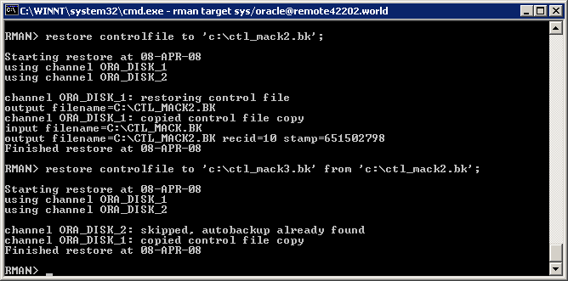

Recipe 11-2: Previewing Backups Needed for Restore

Normal Mode:
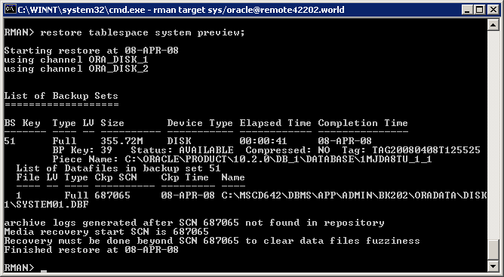

…a few more restore operations in Normal mode:
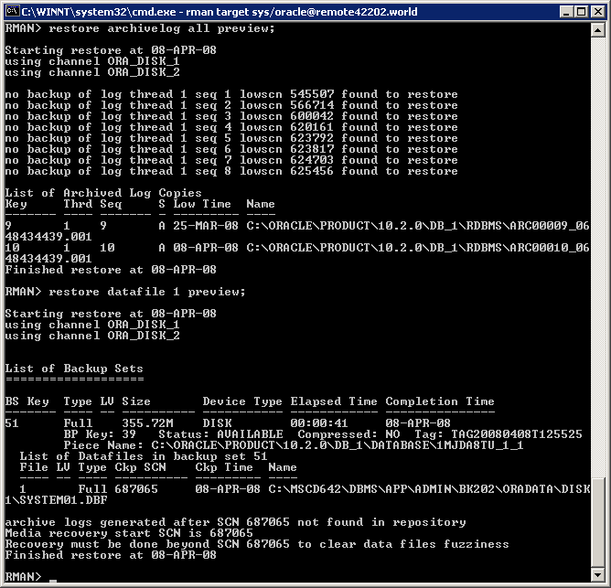

Summarized Mode:
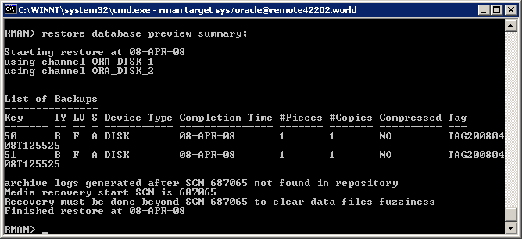

Recall Mode:
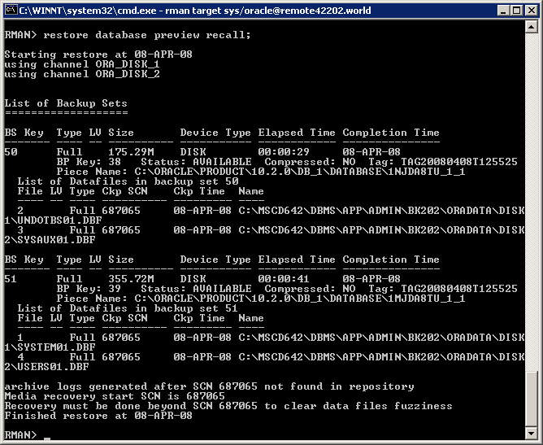

Recipe 11-3: Verifying Integrity of Backups

Using restore … validate (a couple of examples)
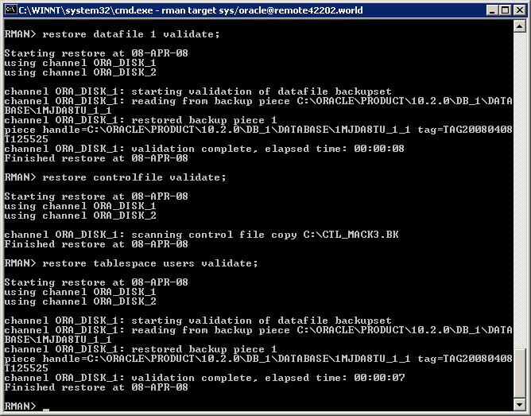

Using Validate:
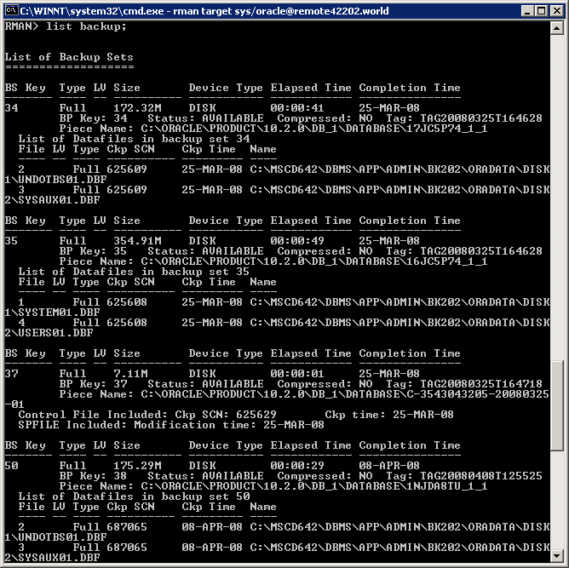
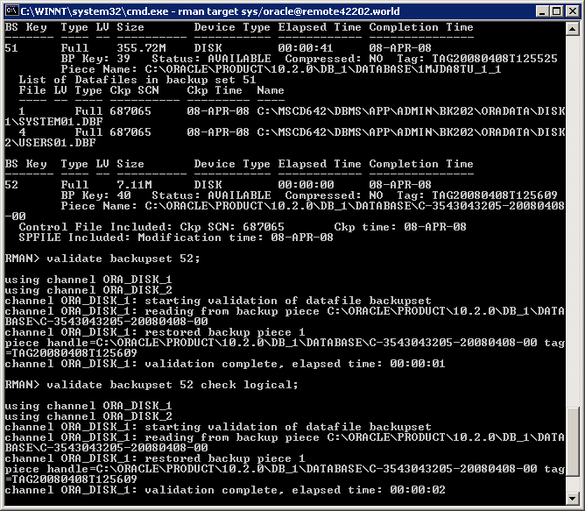

Recipe 11-5: Performing Database-Level Recovery
Using current control file
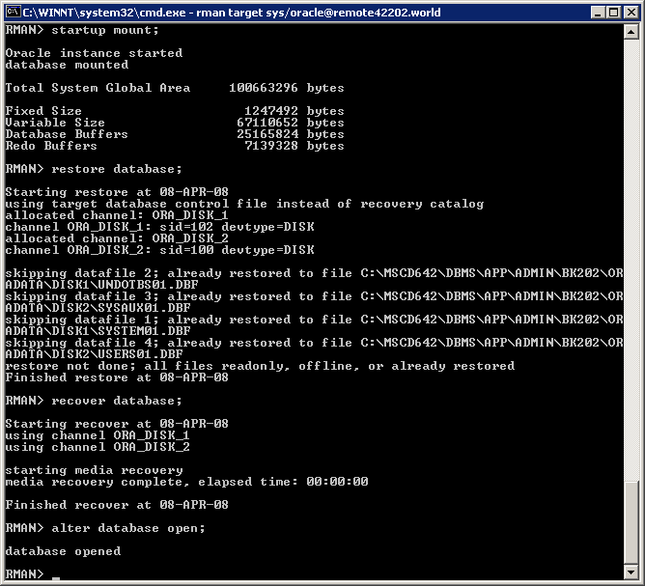

Using backup control file:
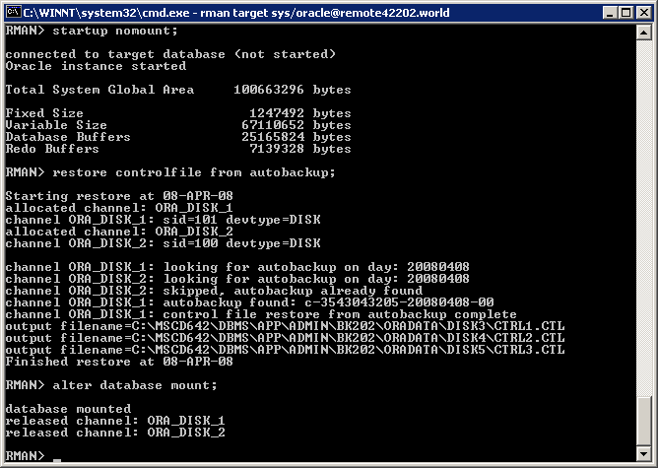
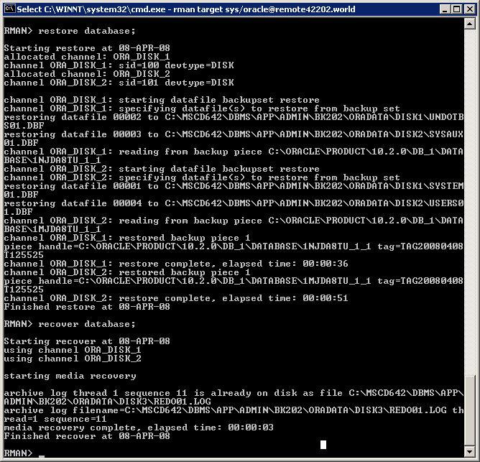
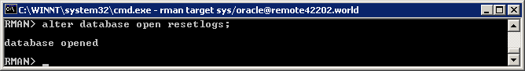

Recipe 11-16: Restoring Archived Redo Log Files:
(Note: I couldn’t get the “All” to work no matter how much I tinkered with it. Not really sure why. I kept getting the RMAN-06025 error Jorei and I discussed in the discussion forums. I was unable to resolve the issue, however then my sequence restores said everything was already restored.)

…restoring to a default location
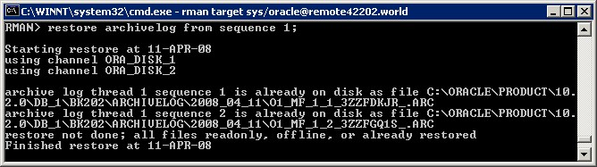

…restoring to a nondefault location
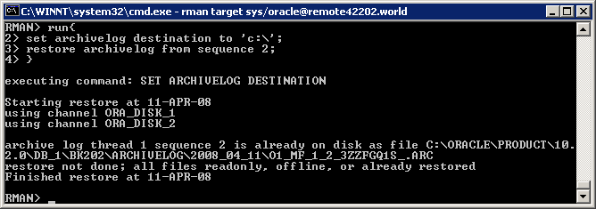
Recipe 13-1: Checking the Flashback Status of a Database

SQL> select flashback_on from v$database;

FLASHBACK_ON
------------------
NO

Recipe 13-2: Enabling Flashback on a Database

- Verify the db_recovery_file_dest

SQL> show parameter db_recovery_file_dest

NAME TYPE VALUE
------------------------------------ ----------- ------------------
db_recovery_file_dest string %ORACLE_HOME%
db_recovery_file_dest_size big integer 1G

- Verify that database is in archivelog mode

SQL> select log_mode from v$database;

LOG_MODE
------------
ARCHIVELOG

- Verify the mode the database is in

SQL> select open_mode from v$database;

OPEN_MODE
----------
READ WRITE

- Get database into mount mode

SQL> shutdown immediate
Database closed.
Database dismounted.
ORACLE instance shut down.
SQL> startup mount
ORACLE instance started.

Total System Global Area 100663296 bytes
Fixed Size 1247492 bytes
Variable Size 62916348 bytes
Database Buffers 29360128 bytes
Redo Buffers 7139328 bytes
Database mounted.

- Enable Flashback

SQL> alter database flashback on;

Database altered.

- Open the database

SQL> alter database open
2 ;

Database altered.

Recipe 13-3: Disabling Flashback on a Database
SQL> alter database flashback off;

Database altered.

SQL> select flashback_on from v$database;

FLASHBACK_ON
------------------
NO
Recipe 16-1: Identifying RMAN Processes

SQL> run {
1 select b.sid,
2 b.serial#,
3 a.spid,
4 b.client_info
5 from v$process a, v$session b
6 where a.addr=b.paddr
7* and b.client_info LIKE '%rman%'

SID SERIAL# SPID
---------- ---------- ------------
CLIENT_INFO
----------------------------------------------
101 18 5016
rman channel=ORA_DISK_1

86 2 3924
rman channel=ORA_DISK_2

Set command id
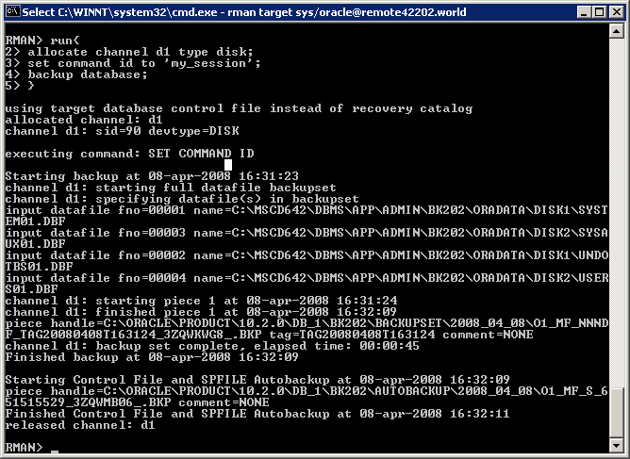

Recipe 16-2: Measuring Backup Performance
SQL> column session_recid heading ID format 9999
SQL> column input_bytes_per_sec_display heading Input_Bytes_Sec format a10
SQL> column output_bytes_per_sec_display heading Output_Bytes_Sec format a10
SQL> column time_taken_display heading Time_Taken format a20
SQL> column end_time heading End_Time format a20
SQL> select session_recid,
2 input_bytes_per_sec_display,
3 output_bytes_per_sec_display,
4 time_taken_display,
5 end_time
6 from v$rman_backuP_job_details
7 order by end_time;

ID Input_Byte Output_Byt Time_Taken End_Time
----- ---------- ---------- -------------------- --------------------
4 15.04M 10.33M 00:00:49 12-MAR-08
32 2.10M 1.47M 00:11:59 18-MAR-08
41 12.18M 9.04M 00:00:40 24-MAR-08
43 12.49M 9.27M 00:00:39 24-MAR-08
46 7.12M 5.05M 00:03:50 24-MAR-08
51 1.04M 331.79K 01:07:17 25-MAR-08
122 16.08M 11.22M 00:00:48 08-APR-08
125 14.64M 10.00M 00:00:45 08-APR-08
128 15.14M 10.57M 00:00:51 08-APR-08
107

10 rows selected.
Recipe 16-3: Monitoring RMAN Job Progress

Check status on a current backup in progress (Note: I manually ran a backup right before I executed this script).
SQL> column sid heading sid format 999
SQL> column serial# heading serial# format 99999
SQL> colunn totalwork format 9999999
SP2-0734: unknown command beginning "colunn tot..." - rest of line ignored.
SQL> column opname format a40
SQL> select sid, serial#, totalwork, opname,
2 round(sofar/totalwork*100,2) "% Complete"
3 from v$session_longops
4 where opname LIKE 'RMAN%'
5 and opname NOT LIKE '%aggregate%'
6 and totalwork !=0
7 and sofar <> totalwork;

sid serial# TOTALWORK OPNAME % Complete
---- ------- ---------- ---------------------------------------- ----------
87 57 62080 RMAN: full datafile backup 19.59
104 21 35840 RMAN: full datafile backup 38.57
Recipe 17-8: Viewing RMAN Command History
Note: I’m only selecting a few rows of this as I’m sure you don’t need to see 400 rows of it!
SQL> select sid,
2 recid,
3 output
4 from v$rman_output
5 where recid >= 372
6 order by recid;

sid RECID OUTPUT
---- ---------- ------------------------------------------------------------------------------------
87 372 Deleting the following obsolete backups and copies:
87 373 Type Key Completion Time Filename/Handle
87 374 -------------------- ------ ------------------ --------------------
87 375 Archive Log 15 08-APR-08 C:\ORACLE\PRODUCT\10.2.0\DB_1\RDBMS\ARC00009_0
87 376 Archive Log 16 08-APR-08 C:\ORACLE\PRODUCT\10.2.0\DB_1\RDBMS\ARC00010_0
87 377 Backup Set 59 08-APR-08
87 378 Backup Piece 47 08-APR-08 C:\ORACLE\PRODUCT\10.2.0\DB_1\BK202\BACKUPS
87 379 Backup Set 60 08-APR-08
87 380 Backup Piece 48 08-APR-08 C:\ORACLE\PRODUCT\10.2.0\DB_1\BK202\AUTOBAC
87 381 deleted backup piece
87 382 backup piece handle=C:\ORACLE\PRODUCT\10.2.0\DB_1\BK202\BACKUPSET\2008_04_08\O1_MF_NNND

sid RECID OUTPUT
---- ---------- ------------------------------------------------------------------------------------
87 383 deleted backup piece
87 384 backup piece handle=C:\ORACLE\PRODUCT\10.2.0\DB_1\BK202\AUTOBACKUP\2008_04_08\O1_MF_S_6
87 385 Deleted 2 objects
87 386
87 387
87 388 RMAN-06207: WARNING: 2 objects could not be deleted for DISK channel(s) due
87 389 RMAN-06208: to mismatched status. Use CROSSCHECK command to fix status
87 390 RMAN-06210: List of Mismatched objects
87 391 RMAN-06211: ==========================
87 392 RMAN-06212: Object Type Filename/Handle
87 393 RMAN-06213: --------------- ---------------------------------------------------

sid RECID OUTPUT
---- ---------- ------------------------------------------------------------------------------------
87 394 RMAN-06214: Archivelog C:\ORACLE\PRODUCT\10.2.0\DB_1\RDBMS\ARC00009_0648434439.001
87 395 RMAN-06214: Archivelog C:\ORACLE\PRODUCT\10.2.0\DB_1\RDBMS\ARC00010_0648434439.001
87 396
87 397

26 rows selected.

SQL>

Recipe 17-9: Enabling RMAN’s Debug Output
From the Prompt:
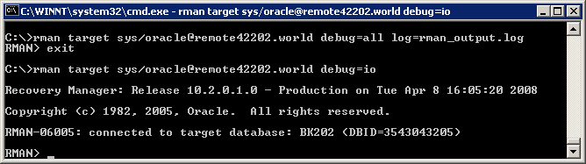

When allocating a channel …
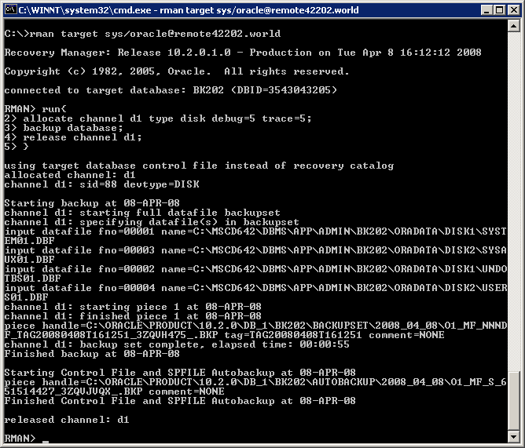

When configuring a channel:
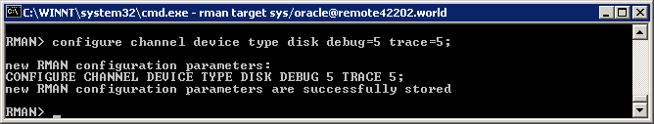

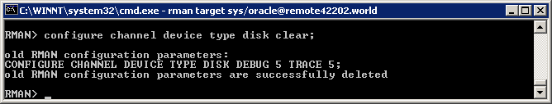

From within RMAN (note: I didn’t paste my log file as it’s enormous, can email it to you if you’d like to see it):
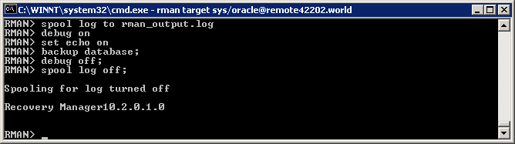

More specific debug, with a level defined for PLSQL debugging (note: I again won’t attach my log file)
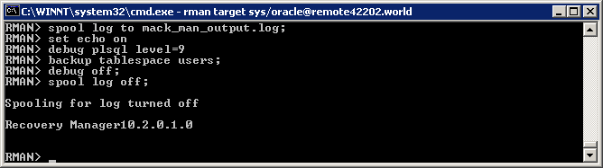

Recipe 17-10: Enabling Granular Time Reporting

Adjust the nls_date_format at the operating system level
